**Descriptive analysis of the I/B/E/S US EPS forecast data**

1. I have downloaded I/B/E/S data from WRDS with FPI equal to 1 and 2 and forecast date since 2011.
2. The top 30 firms with the most analyst is listed below.

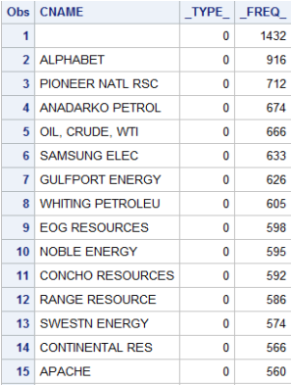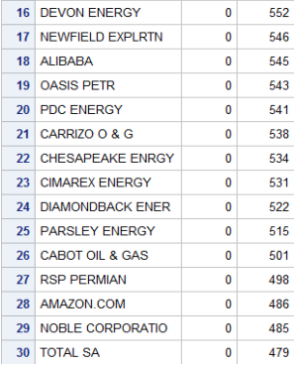

1. Numbers of distinct companies, analysts, and estimators are shown below.

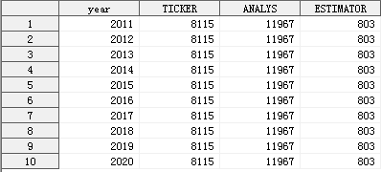

4. Summary statistics:

